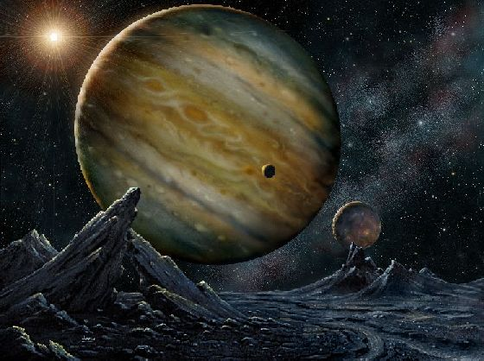

By Maria Marinari

Assistance from the University of Oxford ICT Department and Ken Kahn.

Contents

Abstract: 2

Introduction. 3

Explanation of orbital elements: 4

Method of the Model 5

The Inspiration for the model 5

Initial Set Up of the Model 6

Setting up our Solar System 7

Exoplanet Models 8

The Results that Lead to Development 10

Developing our experiments using Kepler-62 10

Improving the model 11

Using the super computers. 12

The ResultsLeading to Analysis 12

Kepler-36 12

What the Analyses Kepler-36 c’s orbit showed us 12

What the Analyses Kepler-36 b’s orbit showed us - 13

Overview 13

Kepler-62 13

Discussion: 14

Conclusion 14

Using the computer model: 15

References: 15

Appendices 16

Reflection on Learning: 16

Acknowledgements: 16

# 

# Abstract:

The aim of this project is to show that by using agent based computer models to aid research we can find or minimise the range of a planets orbital perimeters. Not enough is known about planets outside our own solar system, exoplanets. We are incredibly uncertain of the pattern of their orbits, mass and density. Because the field is a relatively new one, the technology used to observe planets outside our own solar system is still developing meaning there is still lots that can be learnt. In paper I show how it is possible to use agent based modelling in order to create true to life 3-D simulations of entire exoplanets solar systems to solve this problem and find these uncertain parameters, by investigate the impacts of adjusting the unknowns of a planet’s 3-D orbit in the computer model we found it would be possible to pin down these parameters. We used this method on the star systems kepler-36 and kepler-62. The impact of this research showed that it is possible to use this method to find a planet’s orbit and mass more exactly however more extensive testing can, the main legacy of this project is the flexible model that was created for testing can now be used as learning and research tool.

Key Words:

Agent based model, kepler, simulation orbits gravity orbital elements

# Introduction.

In this report I hope to show to you how a computer model can help to visualise and improve what we know about planets outside our own solar system. This is something we found incredibly interesting and worthwhile as the number of confirmed exoplanets discovered has been growing massively over the past couple of decades. As the methods of finding these planets become more and more refined there is more that we can discover about a planet.As it stand it is possible to find the mass, radius, climate and orbital patters of many of these planets by using clues in data we receive from telescopes monitoring outer space such as the kepler telescope. What we can understand about a planet’s obit from detection method such as Radial velocity (the wobble of the star due to the gravitational pull of orbiting planets) transit methods (observing the planet cross over the sun) is fascinating, but as we discovered does not yet give us the whole picture.We want to help complete the picture using the computer model we created to find a planets orbit more accurately.

At the beginning of the project we started by inspecting the orbital patterns of planets by creating a version of our own solar system using flexible computer model made using netlogo and information from the data bases horizon which is able to generate the state vectors of any body in our solar system. This then developed into looking at planets outside our own solar system ‘exoplanets’ using the same flexible model and data bases such as exoplanets.org and kepler.nasa.gov which give the orbital elements of a planets orbit. Using orbital elements became very important later on when mapping out exoplanets orbits as these variables are more commonly used among astrophysicists.

It was when researching different planet orbital elements we found was there was a significant amount of information on these planets and there orbit that we couldn’t find accurate information for because using the current astrophysical methods are not incredibly certain. For instance to find the mass of a planet using Radial velocity an astrophysicist must rely on the planet being massive enough and close enough to the star for the obit of the star to be effected be its gravitational pull. We decided that not only did we want to create these systems but also improve the information publicly available to people.

When making this model our primary aim was to enable people to discover more about exoplanets, their orbits and how orbits are made possible by the forces of gravity. We discovered that by replicating the laws of gravity though orbiting planets we could track a planets orbit and find if it was accurate and thus if the initial settings of the model. We trialled this method extensively on star systems kepler-36 and kepler-62. The creation of the model and the results of the experiments are laid out in this paper.

## Explanation of orbital elements:

The orbit of any body can be defined by six orbital elements known as keplerian element after Johannes Kepler. By more accurately defining these elements we can show how the planets are moving in 3-D accurately and with more development even predict the position of exoplanets at certain points in times. This could potentially be an incredibly useful tool for astrophysicists and astronomers for further observing and studying these planets.

A planet and some of its orbital elements can be found through various methods of detection if you want to find out more go to <http://www.superwasp.org/exoplanets.htm>. Below is a basic explanation of the six orbital elements:

This diagram show how orbital elements are used to define a planets orbit.

Semi-major axis (a): Defines the size of the orbit

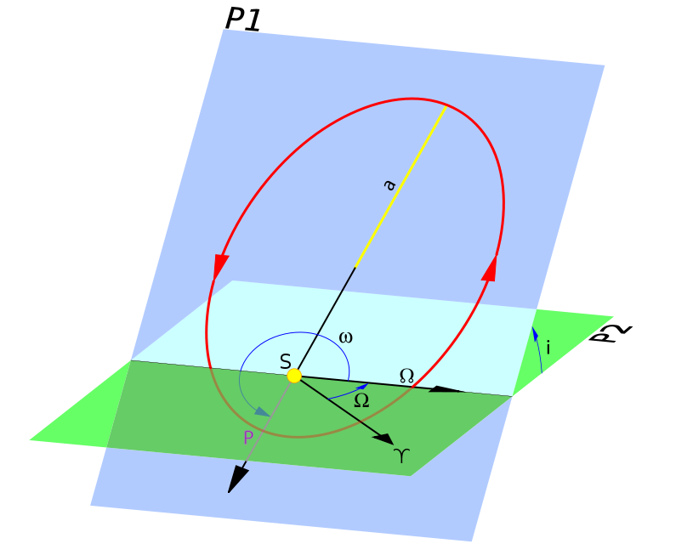Eccentricity (e): Defines the shape of the orbit

Inclination (i): Defines the orientation of the orbit with respect to the body’s equator.

Argument of periapsis (w): Defines where the low point if the orbit is with respect to the body’s surface.

Longitude of the ascending node(Ω): Defines the location of the ascending and descending orbit location with respect to the earth’s equatorial plane.

Mean anomaly (v): Defines where the satellite is within the orbit with respect to periapsis

Even with all theinformation that we uncover about these planets orbits there is still more we cannot find. For some planets we have found these orbital elements are very uncertain because finding them relies on estimates and unpredicted calculation. Using traditional method there are some elements we can’t even find for instance the longitude of ascending very easily unless two planets cross over the sun at the same time. By use a process of trial and error experiments in a computer model we hoped to these elements more accurately than any other existing method. This should help to improve the information accessible to the general public and researches, thus in the world wide push to map out our universe and find earth like planets.The ultimate goal is find out more about exoplanets that could show signs of possible life such as.

# Method of the Model

## The Inspiration for the model

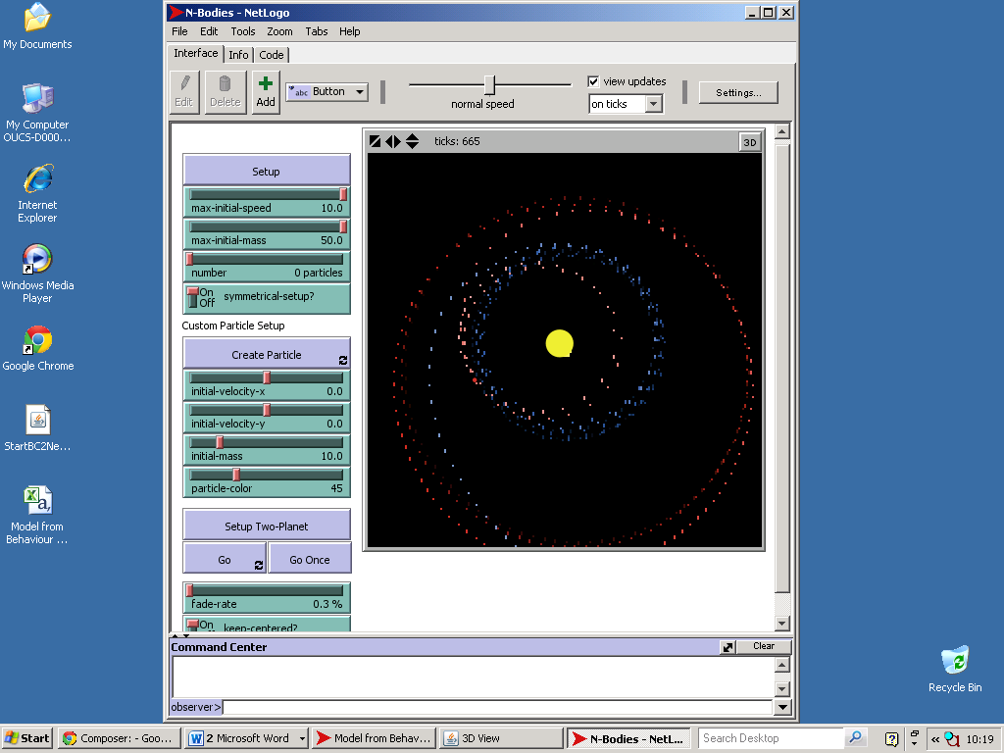We were really interested in creating a computer model based around replication of the solar system and gravity. We looked at a collection of sample models based on this theme. One model that was incredibly interesting was called N-bodies, shown to the right. the aim of the program was to let the user create planets and demonstraight that the force of gravity between more all of these planet can be found by using an agent based model, thus creating orbits. Calculating all the forces actting on a planet is not something that can be done easily without the aid of a computer program, so watching this was incredible.The program N-bodies had a lot of problems with the coding, the scale and time frame, we found also that the equation being used to calculate the forces acting on a body was wrong. As a result the orbits of the bodies were unstable and unrealistic.

This is a print screen of the model N-bodies in action. The orbited body and the orbiting bodies are far too similar in mass and this means it is impossible to create a stable orbit, this is why you can see the partials being thorn off the screen.

We re-wrote sections of the code to solve these problems and then set up a scale version of the sun and the earth to test the model. After this success I wanted to learn more about how we could create interesting orbits and what was needed to keep a stable one? Looking at this model brought up a lot of questions about creating our own: what time frame would we want to look at and how would we be able to inspect the model easily could we make it just as user friendly. This is where the idea of setting up our own world in which we could create solar systems came from. We wanted to see what we could learn about a planet from its orbit. The idea that it was possible to create particles track their orbit and find the forces acting on them was intreging this lead to us investigating orbits further and creating a vertion of the modle our selves.

## Initial Set Up of the Model

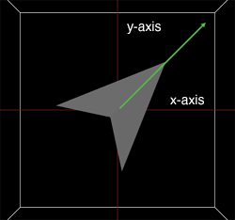We made a new model from scratch using a program called the behaviour composer. (for more details visit <http://m.modelling4all.org/>).The model we made was based on the reworked model of N-bodies using the principle that one body will accelerate due to the mass of another body in accordance with a = g * M2 / r₂ .

The reason a planet orbits a star in a circular pattern is because of the resultant of the two forces acting on it initial velocity and it acceleration towards the centre of mass of the system (usually a star).We wanted the model we created to be easy for anybody so we needed to use more innovative method of controlling and updating the velocity of any planets in the system (which we called bodies). N-bodies which used Cartesian based modelling which calculated the resultant of the force vectors acting on each body using complex and unnecessary mathematic formulae. Our model used turtles, which are small agent in the computer program which are able to do all the trigonometry of finding a body’s new position and velocity for you. The obvious advantage of this is that it is easy to update a body’s velocity as a result of the other masses around it without needing to understand the trigonometry yourself. This made the model easier to understand and very flexible for anyone creating a planet in the system, a velocity turtle would set up in the system and the system could adapt to multiple bodies easily this would create an orbit around the centre point of the world (0,0). This Idea was inspired by the paper ‘Velocity Space and the Geometry of Planetary Orbits’. In the final version of the model we visualized the velocity turtles at the bottom of the screen, you can see that the velocity is acting at a right angle to the centre of mass and is changed due to the resultant force of gravity acting on it.

The snippet below show a section of code used in gravity behaviour which updates the velocity. Because we were creating a model that was different to any other we had to be creative with new types of coding in the behaviour composer based around orbits. We needed to write lots of new micro-behaviours (these are instructions given to a prototype i.e. planet that let it how to behave). To see all of the micro-behaviours we created go to <http://resources.modelling4all.org/libraries/orbits> follow the links to see the code that I actually wrote. An example of one we created one called body properties which allowed anyone using the model to set up a body by giving basic information, the mass, size the xy coordinates from (0,0) and the xy velocity. You can find this by looking into the model.

[**set**](http://ccl.northwestern.edu/netlogo/docs/dictionary.html#set)[**heading**](http://ccl.northwestern.edu/netlogo/docs/dictionary.html#heading) heading-to-other

[**set**](http://ccl.northwestern.edu/netlogo/docs/dictionary.html#set) pitch pitch-to-other

[**jump**](http://ccl.northwestern.edu/netlogo/docs/dictionary.html#jump) g [**\***](http://ccl.northwestern.edu/netlogo/docs/dictionary.html#Symbols) mass-of-other [**/**](http://ccl.northwestern.edu/netlogo/docs/dictionary.html#Symbols) distance-to-other [**^**](http://ccl.northwestern.edu/netlogo/docs/dictionary.html#Symbols)2

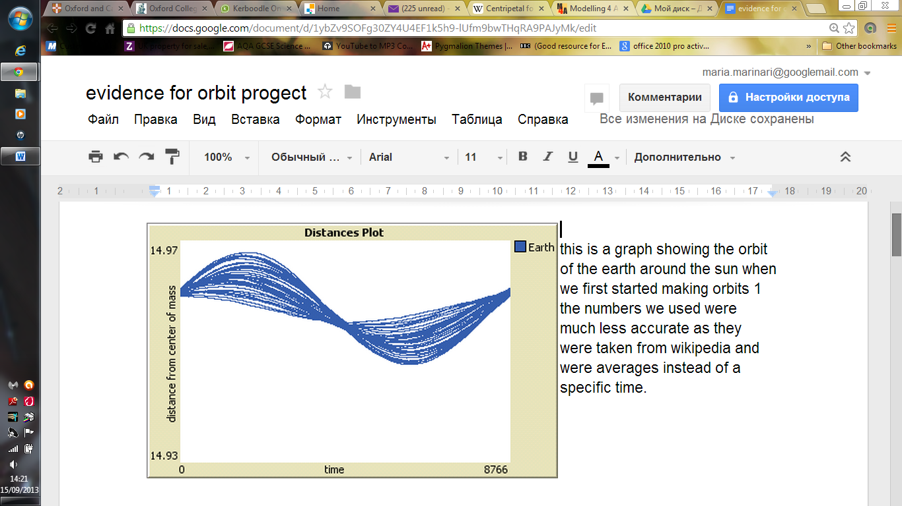To know if it worked properly we needed to compare to real life data to find out whether the planets were following correct orbit. We did this by setting up graphs displaying the planets distance from the sun and counting the earth’s orbits model this would make analysing the planets orbits easier. The graphs should look like sinusoidal curves because no true orbit is completely circular. To the right you can see the first graph that was produced, as you can see it is rather inaccurate. What we found really helped to improve out model (refer to document 1). We had originally relied on the speed of the planet’s orbit from a source on Wikipedia this showed us that to make the model truly accurate we needed to use more reliable data to set up the planets and that we needed to calculate the centre of mass of the system as it would be varying by a small tiny amount.

## Setting up our Solar System

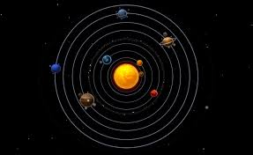We were now able to set up a 2-D version of our own system this was something we thought useful as one of the aims of our project was to use the models as a teaching tools, this would show how the forces of gravity affect the planets in our own solar system and would also be a prototype for other solar systems to come. When we first used this model we set up planets using there state vectors which we collected from an online project called horizon run by NASA which generated ephemerides for solar-system bodies. We setup a virtual version of the eight planets using the state vector of a planet at a specific time (1stjan 2013 00:00). The state vectors of an orbiting planet are the velocity and the coordinates in the x and y from the centre of mass of the system (the sun). By inspecting the graphs we realised that something was wrong using with some of the planets orbits, in particularVenus. It’s orbit was much more elliptical that expected we compered this to real life data and realised that there was a problem with our model as Jupiter will affect the orbit of Venus if they are in the same 2-D plane (refer to document 2) the conclusion of this was that a 3-D model needed to be made. As our own solar system work nearly exclusively on one plane we never foresaw this being a problem with our model.

Moving the model in to 3-D was trickier than expected as 3-D Netlogo is much less developed than the 2-D version as it is newer.This was going to take a lot of adjustments to it as we had to add a third dimension, z to every section of code that we had already written. Later we realised just how useful modelling the planets in 3-D would become for sourcing information about the planets orbit.

# 

# Exoplanet Models

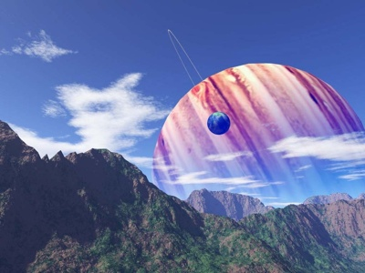Setting the exoplanets solar systems was one of the most exciting parts of the project, we attempting to visualise something that we have only just discovered and can’t even see using the most high tech. telescopes. It was only at this point we started to learn all about how the planets were detected and how there orbits were defined so that we could set up the model as accurately as possible. When doing this we found that the information about planets orbits available to us was very different to what we expected instead of using state vector as we had been using before the planets orbits were given by orbital elements, this was a temporary draw back to the project. We decide that instead of re-writing the program to understand orbital elements instead of state vectors we would adapt it by writing a section of code that would convert the orbital elements into their equivalent state vectors. We eventually solved the problem by finding an online converter that allowed you to input the orbital elements of a planets and the object it was orbiting and covert them to state vectors in relation to what it was orbiting which was just what we needed (<http://orbitsimulator.com/formulas/OrbitalElements.html>). We copied the java script from the web site and rewrote it in Netlogo language. Getting a version of the model that was adapted to this kind of data was incredibly hard as the person who wrote the script for the convertor did not expect others to use it. Deciphering and re-writing the code took a long time.

This is an artist impression of kepler-62 planets. We have no idea what they really look like and doubt they look this cool.

Initially using this code didn’t work correctly because the time scale and the distance scale used in the convertor was different to the scales used in the model meaning the initial velocity was incorrect. We found this by setting up two versions of Jupiter in the same model one using the Cartesian state vectors that we knew and one using keplerian orbital elements and the conversion. We discovered that because we had made the time scale and the distance scale of the model adjustable (so that it could be appropriate for any sized solar system) this meant that the magnitude of the velocity in the Jupiter using orbital elements was off by a factor of the distance and time scale.

Now that we apparently had the model working using element we set up a star system, kepler-62. The star system was recently discovered earlier in the year and two out if the five planets were regarded as being in the habitable zone so we thought using the model to find out more about these mysterious planets would be an interesting endeavour (for more information on the planetary systems ref. go to document 3).

We wanted to confirm that our model was working correctly and how we could develop the model further, to benefit researchers. To do this the easiest thing would be to talk to an expert in the field. Suzanne Aigrain, Lecturer in Astrophysics at All Souls College, Oxford University had published papers discussing the orbits of planetary systems, we arranged a casual meeting. I showed her my model of kepler-62. From what she told me it was clear that no one had ever tried to visualise exoplanets systems in this way, she was very interested in what I was trying to do.

She explained how some of the orbital elements of a planet are obtained using the transit and oscillation of the star and planet and why this meant that most of the orbital elements of the planets were incredibly uncertain and why 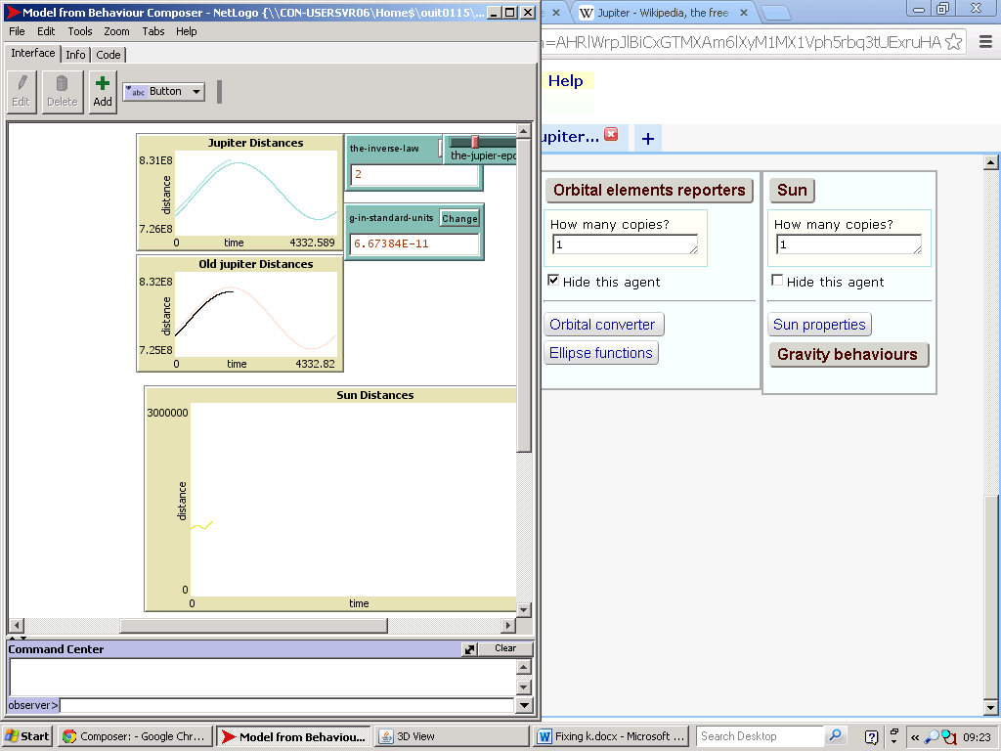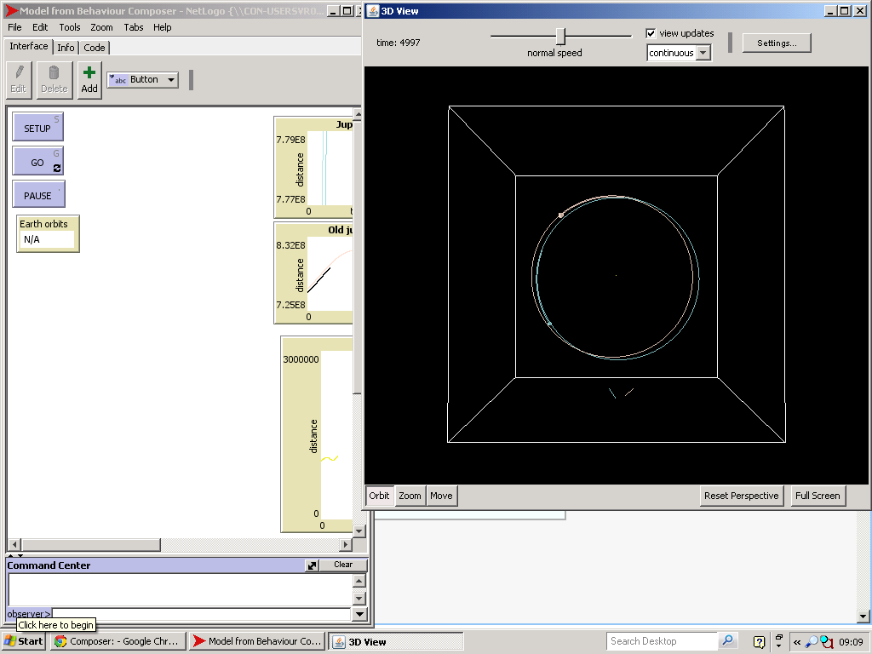some weren’t even known. She referred me to online resources from a book called exoplanets which explained further how the transit and oscillation can be used to find out more about the planet and why it is tricky to find things like the mass of the orbit its self. This showed us that unfortunately some of the properties of the planet and its orbit may never be able to pin down. However it was clear that my model worked in all mathematical aspects and that I could still improve the certainty of the available information on exoplanets using this model. We then looked at extrasolar planet systems she believed it would be interesting for me to model, ones with interesting orbits that knowing more about would be useful. I came away knowing exactly which systems I wanted to model kepler-36 (refer to document 3) and had the resources to research the orbits of the planets in more depth.

Knowing as much as I could about the planets was important to reduce the number of unknowns in the model and so that I would know what to expect from the model and what the results of any experiments should hopefully look like.

# 

# The Results that Lead to Development

Now we had two models ready to test the experiments on we were hoping to find the mass of the planets and the distance from the sun more accurately. We also wanted to find an appropriate longitude of ascending node and mean anomaly of the planets orbits for the model to work because this would enable us to represent the solar system in 3-d. We started running simple trial and error method to run experiment involving the BehaviorSpace, a software tool integrated with NetLogo that allows you to perform experiments with models. It runs the model repeatedly, systematically varying the model's settings and recording the results of each model run. It let us explore the model’s possible behaviours and determine which combinations of settings would lead to the most accurate orbit. We initially defined an accurate orbit as the body’s distance from the sun, if the body flew out of its expected ellipses this was an inaccurate orbit. We were able to calculate the minimum and maximum distance that the planet should be from the sun using the semi-major axis and the eccentricity (values that we believed to be more certain). We set the range for an accurate orbit to be 25% larger than the maximum and 25% smaller than the minimum.

## Developing our experiments using Kepler-62

We first concentrated on running experiments on kepler-62, this was the first model we had set up and running. Experiments worked by running the model until a body was out of its expected orbit or 10000 hours had passed this meaning that kepler-62 f would have completed nearly two orbits. The excel spread sheet from these experiments are attached as original experiments.

As Kepler-62 is a 5 planetary system this meant changing just a few parameters would produce a huge experiment. So we took our time over deciding the most using settings we wanted to test and the range that we wanted to set for them. We started running just one experiment varying the mass of the planets because this was the most uncertain value (refer to doc.3) .The range we decide to test was based on the maximum possible mass of the planets as well as information sourced from ‘The Inner Structure of the Planets Kepler-62 e and Kepler-62 f R.-S.Taubner’ about the density of the outermost planets e and f related to planet found to be similar to them. We then made judgments based on their relative sizes. The expectation was if masses were different enough gravitational pull of one planet would pull one out of its expected range enough to pause the experiments.

The results of this first experiment showed no planet flying out of the range (go to experiment-mass). This showed us that no was planet could be thrown entirely out of there orbit due to the gravitational pull of another nearby planet, the effect was not as strong as expected. This was not an accurate enough experiment. We changed the definition of an accurate orbit to be 25% of the expected period of the orbit. We updated the experiment to show us whether an orbit length and size was ‘okay’ we then ran further experiments on the longitude (experiment-longitude) the results from that experiment show that the range we were using was probably too large. We then improved the experiments by running more combinations, value and changing the expected range to only 10% (thus more accurate) we ran the longitude experiment again and it gave us promising result show that on around a third of the runs came back with the year orbit out of range finally we had some result we could work from! Or so we thought…

## Improving the model

We then continued to run experiments by varying the Eccentricity and Argument of priapism and decided to improve the accuracy of the tests by reducing the range of an accurate orbit down to just 4%. When we got the results back from the first of these experiments it was clear that something was wrong.Both experiments testing the Eccentricity and Argument of priapism show that one or more planets were out of its expected range every run. This showed that there was something wrong with the model not the tests as it was calculating a more elliptical path for the orbit than intended.

We went back to the model and tried testing out different things. Found that the initial velocities and coordinates for the planets were 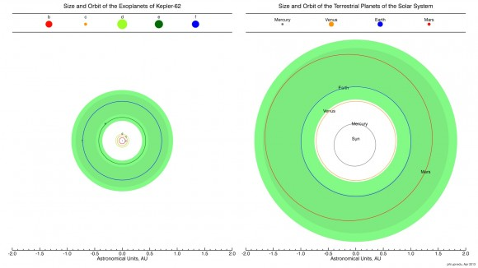correct meaning the orbit of the planets were being calculated incorrectly by the computer from this point onward. The original model of the solar system we made didn’t have this problem. We analysed the differences between the two models to see what could be causing this problem. The diagram on the left showing the orbit of kepler-62 planets compared to our own solar system the main difference is that the planets are a lot closer to the sun. This causes Kepler-62b complete an orbit more than 15 times faster than Mercury. This meant that for every tick the inner planets of kepler-62 were travelling too far before their velocity could change(because the velocity is only recalculated every tick= an hour in the model) this cause the orbits of the planets to appear as if there was less force acting on them than there actually was cause the planet to travel further from the sun thus a more elliptical orbit.

do

To solve this problem was simple by updating the time scale from each tick being an hour to only three minutes long. A shorter time the velocity turtles would update the velocity of the bodies more often making the model and the experiments more accurate because the position of the bodies would be updated so many more times per orbit. However this cause a small problem,the experiments would take 20 times longer to run. Running the experiments on a normal computer would now take weeks rather than a night. To get around this problem we applied to get time one of the university’s many super computers, SAL.

## Using the super computers.

At first we sent version of pervious experiment with the new time scale and an even smaller range for what was considered an accurate orbit. These showed that all of the planets had a year that was in a range of 1% of the range. Although this showed us our model was working it gave us no information about the correctness of the orbit. This lead to further updates to the programing of the experiment. We decide that we needed to know exactly how long it took a planet to complete an orbit on the run of our model, we compare it the orbital periods of the actual planet. After each experiment we would receive the length of every complete orbit a planet when though, in second by finding the most accurate run we would find the more suitable values for different variable. This would also mean that we could spot any patterns in the change in the orbital period over time and match it with changes that we knew would happento the actual planets (refer to the doc. 3).

The results from the first experiment came back to us in a matter of hour showing we had the capability to run larger experiments, we could change more variable in parallel so vary lots of different combinations parameters in one larger experiment. We were able to run sections of the experiments on different computers by splitting the experiment into sections we could save time so changed the time scale again to just one minute to make the runs more accurate. We designed an experiment for each of exoplanet solar systems.

# The ResultsLeading to Analysis

## Kepler-36

The raw results of these experiments were given in a excel spread sheet and can be found at <http://resources.modelling4all.org/projects/exoplanet-progect> in the attachments section. These experiments tested value of the longitude, semi-major axis, mass and the mean-anomaly. We were able to analyse the data by inspecting the runs that gave us the orbit length of the planet in seconds correct to 3 or 4 compared to information sourced from<http://kepler.nasa.gov/Mission/discoveries/>.

There are only two planet in the systems in which meant the number of combinations of different parameters was much smaller in this experiment meaning the model would need to be run far fewer time than kepler-62. However we still split the experiment in to three sections to run on different computers, to be sure that we would get result in time to analyse the properly.

What the Analyses Kepler-36 c’s orbit showed us–-

MASS- of those runs, those where the mass of kepler-36 b was 2.49e25 produced an orbital period for kepler-36 c that was correct to 4.s.f. in these run the mass of kepler-36 c itself was very varied but this was something we had expected because the acceleration of a planet is not due to the size of the planet but the planet around it in this case kepler-36 b.

SEMI-MAJOUR AXIS-the experiments showed that runs where the semi-major of kepler-36 c was 19210000km and kepler-36 b at 17560000km gave kepler-36-c’s orbital periods correct to 4.s.f.

LONGITUDE-For all of these highly accurate runs for kepler-36 c the longitude of kepler-36 c’s orbit was at a constant of 145 degrees whilst the longitude of kepler-36 b varied massively, this show that for the planet to have a correct orbit some longitudes are not expectable in this case 5 and 8 degrees.

MEAN ANOMALY-on every accurate run we found that the mean-anomaly of both planets were 300 degrees. This consistency suggests that this is a more accurate mean anomaly than any other value we tested. The other value we tested 90 degrees were far less accurate either far too large or too small showing that more unstable orbits would be set up with a mean-anomaly of 90 degrees

### What the Analyses Kepler-36 b’s orbit showed us -

Because the orbit of kepler-36 b was smaller the path it created was less accurate this meant we could only find runs which had an orbital period correct to three significant figures not 4 and there were far fewer of them those with the closest range only differed from the true value by an hour or so from the true value.

MASS-the runs that showed kepler-36 b to have the most stable (consistently near the predicted value) orbit around the predicted figure were those run were the mass of kepler-36 c was 5.16e25kg. There were some runs where the mass of kepler-36 c was lower and no other parameter had been changed showed that this would produce an orbit slightly further from the true orbit.

SEMI-MAGOR AXIS-a huge majority of the runs that had a constant orbital period in our expected range had a semi-major axis of 17560000km. There where runs that produced an orbit within the range with lower masses and smaller semi-major axis but these orbits where incredibly unstable.

LONGITUDE-Changing the longitude of this planets orbit between 150 244 and 240 degrees seemed to have no effect, we could see this as experiments where only the longitude was changed to wildly different value the results were exactly the same.

MEAN ANOMALY-the mean anomaly for nearly every accurate orbit was 145 degrees. The fact that very few orbits were as accurate at 150 degrees shows that this small change in the mean anomaly can affect the outcome of this planets orbit.

Overview using this information we were able to deduce that the semi-major axis of kepler-36 c is close to the expected value 19210000km, however the semi-major axis of kepler-36 b is closer to the 17560000km which was the uppermost limit given to test showing that it is closer to than 17270000km (the value quoted by exoplanets.org). We can also see that the mass of keppler-36 b &c was shown to be 2.49e25kg and 5.16e25kg respectively showing that kepler-36 b is smaller than expected and kepler-36 c is bigger than expected. If we were to continue running tests we would run the model with masses close to values of 2.49e25kg and 5.16e25kg and the semi-major axis closer to 19210000km and 17560000km. This will help us to find them even more accurately.

The longitude of planets did not affect their orbital period if between the ranges of 145 and 244 however a particularly low longitude would produce orbits far larger than expected. This shows that the value of the longitude can affect the size and shape of the orbit but more testing need to be to find the exact values.

## Kepler-62

We ran a similar experiment with kepler-62 however there three problems with this that meant the experiments we ran took up a huge amount of memory and run for longer, so long in fact the experiments were not actually completed by the time I was meant to leave the university of oxford it department. The first was that there were more variables to test as much less is known about the planets that orbit kepler-62 .The second was fact that there were 5 planet planets not two which meant there were more variations to run for each test. Finally the further most planet from kepler-62 has a far larger orbit than either of kepler-36’s plant which meant each experiment had to run for longer to produce the same amount of data around 4 orbits of the outer most planet. After running the simulations for 24 hour before timing out we found that the simulation was only an8th of the way though the experiment. We made a compromise that we would reduce the run time of the experiments to only 2 orbits of the outer most as this would mean we would still get a huge amount of data on the inner planets for this reason the results of the experiment are not shown in this paper.

# Discussion:

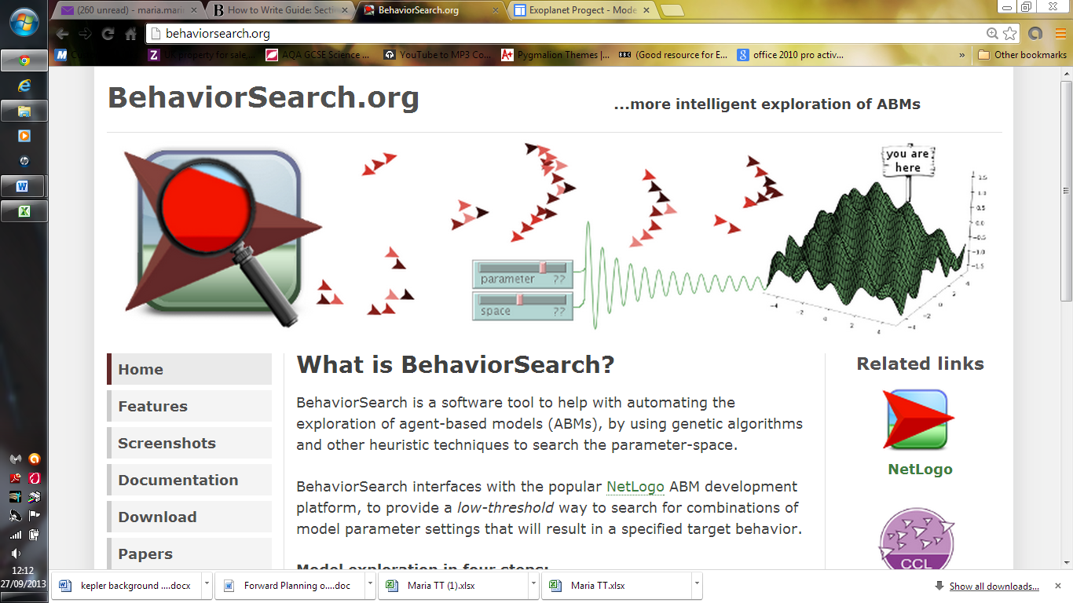The results of our test show that this area of research; using computer model to more accurately find the mass and orbit of a planet outside our own solar system is really promising. The tests gave us a lot of information to build upon. By running more experiments based on these we could pin down the range mass and the size of orbitof the planets to a precision hundreds of times smaller than that provided by current data bases.

We could further develop the impact of our findings if we were to continue to run tests as mentioned in the overview.The results would have a much more profound effect on the way we view these planets orbits.We believe we could improve the efficiency of these tests by using BehaviorSearch instead of BehaviourSpace, it is a software tool to help with automating the exploration of agent-based models, by using genetic algorithms. Although far more complicated to set up the tool would be able to analyse the results for us. For you more details can be found at behaviorsearch.org. Due to the major time limitations of this project we were unable to run a sufficient amount of experiment to confirm some of our findings. I would have improved theaccuracy of experiments by reducing time-scale and adding in feature that our model over looked for instance large moons and asteroids such as Pluto itwould be interesting to see how much they would they effect other planets orbits.

It is sensible to acknowledge the fact that we have not found all the orbital elements of a planet we were inspecting in the kepler-36 system but that I believe that they can be found with more computer time using the Behaviour search tool. We have now published the flexible model on the website modelling4all so it is now publically available. This means that it is possible for more models to be created by members of the public; this was inspired by citizen science projects.We hope members of the public will use the model to learn about orbits by creating them perhaps more star systems with planets in the habitable zone or maybe even start to look at binary star systems.

We believe the model we created of our own solar system is already an excellent learning tool because of the amazing display features and would continue to develop them. If we were to continue working on it we would also improve the plot of the sun graph to explicitly show how the mass of the planets is uncovered from the ‘wobble’ in the stars movement. If we were to carry this part of the project further we would invest time in to letting teachers and student know about the model though advertising it on student forums. We hope this will encourage others to make exoplanets solar systems of their own and build upon the wealth of information we have collected and further improve our understanding of solar systems outside our own.

# Conclusion

The findings tell us that it is possible to use our trial and error method to find possible masses of planets and in some circumstances find the some of their orbital elements. We have proved this by finding a more accurate mass and orbit size of kepler-36 b and c. Results also show that other variables could be found with further testing, I believe this fulfils our aim showing that the uses of computer simulations can help to eventually solve the problem we are having with lack of available data. The more accurate models of the solar system and kepler-36 and 62 can be made publicly available and used as teaching tools as there are sliders which allow you to adjust the value of g and the inverse square law helping to explain why planets create the orbits they do. The model also able to show student how the planets move around each other in 3-D therefore could be used in exciting presentations, creating these models develops understanding of the universe we belong to and the laws that govern it the forces of gravity creating these fascinating orbits.

# Using the computer model:

To properly understand the extent of the work done I believe it is necessary to see the main attraction the model and all the work that was done to create it. To view our solar system and kepler-36 model in 2-D follow the links at the bottom of <http://resources.modelling4all.org/projects/exoplanet-progect> ensure that the 2-D observer is activated not the 3-D, this will enable you to run the models in your browser. To see all the models in their true glory of 3-D, download the netlogo program from <http://resources.modelling4all.org/Home/behaviour-composer-direct-to-netlogo-guide> then copy the aforementioned links into the window when opening netlogo and select the 3-D option. When looking at the model take notice of the adjustable gravity recording features and time and distance scale, why not try making your own solar system by making new prototypes using the information from <http://kepler.nasa.gov/Mission/discoveries/>. To see the micro-behaviours used in the model go to <http://resources.modelling4all.org/libraries/orbits>.

# References:

Information about planets in our solar system:

http://www.corboy.com/solar-system-model/ -relative sizes and colours of the planets

http://ssd.jpl.nasa.gov/horizons.cgi#results – position and velocity of planets

http://ccl.northwestern.edu/netlogo/docs/tutorial2.html - colours of planets

http://www.theplanetstoday.com/ - relative positions of planets

http://nssdc.gsfc.nasa.gov/planetary/factsheet/- gives lots of metric information about plaent that I really need to know!

Imfprmation about the kepler planets modelled:

Kepler 36 (system with two planets which occasionally show strong interactions)

<http://arxiv.org/pdf/1206.4718v1.pdf>

<http://www.sciencemag.org/content/340/6132/587.short>

The Inner Structure of the Planets Kepler-62 e and Kepler-62 f R.-S.Taubner

Borucki, W. J. et al.: Kepler-62: A Five-Planet System with Planets of 1.4 and 1.6 Earth Radii in the Habitable Zone, Science Express.

<http://exoplanets.org/table>

<http://kepler.nasa.gov/Mission/discoveries/>

Information about the orbits of exoplanets and how they are detected:

<http://en.wikipedia.org/wiki/Orbital_elements>

<http://en.wikipedia.org/wiki/Methods_of_detecting_extrasolar_planets>

<http://orbitsimulator.com/formulas/OrbitalElements.html>

<http://www.physicsforums.com/showthread.php?t=511277>

<http://www.mathsisfun.com/geometry/ellipse-perimeter.html>

creating the model:

Velocity Space and the Geometry of Planetary Orbits, Author: Abelson, Harold; diSessa, Andrea; Rudolph, LeeDate Issued: 1974-12-01 the American journal of physics.

<http://ccl.northwestern.edu/netlogo/docs/dictionary.html>

<http://ccl.northwestern.edu/netlogo/docs/dictionary.html>

<http://en.wikipedia.org/wiki/N-body_problem>

<http://www.amsat.org/amsat/keps/kepmodel.html>

# Appendices

## Reflection on Learning:

I have also learnt how to deal with problems by thinking laterally as well as dealing with time management issues I believe that I manage to successfully develop the project from learning from the mistakes I made, which massively improved the model and the results of the project. I have learnt so many important skills though this project that I will value for the rest of my scientific career I have learnt how to program experimental computer models that might come in handy for any experiment I plan to carry out, how to analyse data sufficiently and write a scientific project report.

## Acknowledgements:

During my time at Oxford University Department of IT I learnt how to use and the possible uses of agent based modelling. I started by working on the theme of the forces of gravity and this very quickly led into looking at the orbits of planets and how they might change due to different factors. I would like to give a huge thanks to Ken Kahn and Howard Noble for their support and assistance in making the model and guidance in writing this report without their help I would have been lost I have learnt so much.

 'The authors would like to acknowledge the use of the University of Oxford Advanced Research Computing (ARC) facility in carrying out this work.'